

# Unexploded Ordnance (UXO) Survey – Field H1550 (N) & (S)

**Description of works:**

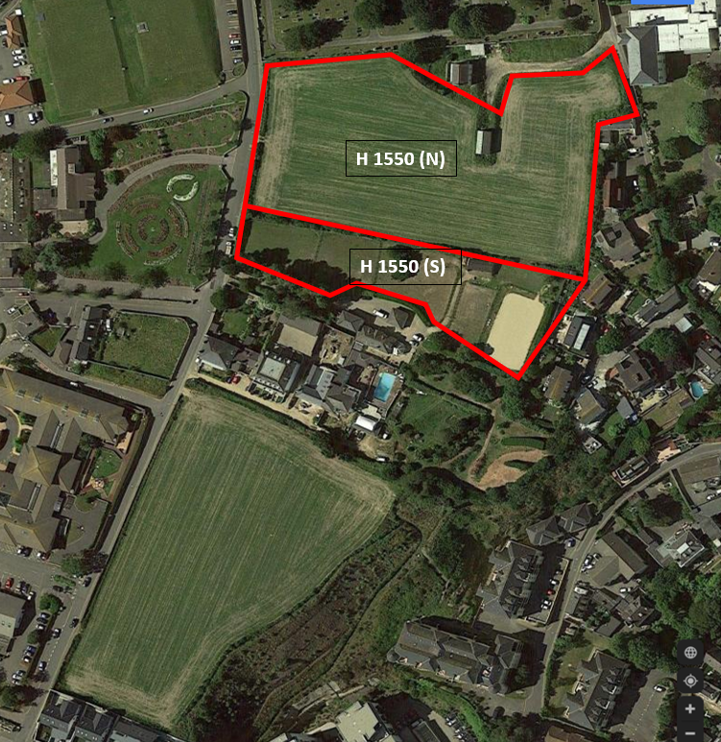We would like to carry out a survey to obtain information from below the ground to determine if there are any unexploded ordnance. The process to gather this information is by scanning and probing the terrain to assess if there are unexploded ordnance embedded in the ground – this is to ensure any planned ground works can be carried out safely and with the minimum amount of risk.

Fig. 01

**Plant and Equipment:**

The planned equipment of use will be a ground penetrating radar capable of detecting ordnance up to 5 metres in depth.

**Duration:**

The duration of the survey in field H 1550 (N) will take approx. 1 week.

The duration of the survey in field H 1550 (S) will take approx. 1 week.

The proposed survey working times are between 08:00AM and 17:00PM Monday to Friday.

No works will be undertaken on Saturdays and Sundays.

ROKFCC have already alerted the neighbours to the survey works and they will continue to keep all parties involved informed throughout the process and do everything they can to minimise disruption.

**Number of personnel:**

There will be 2 nr. personnel attending.